**DAY 7**

**LIVE DEPLOYMENT AND POST-LAUNCH PRACTICES**

**ENVIRONMENT VARIABLE SECURITY AND CONFIGURATION:**

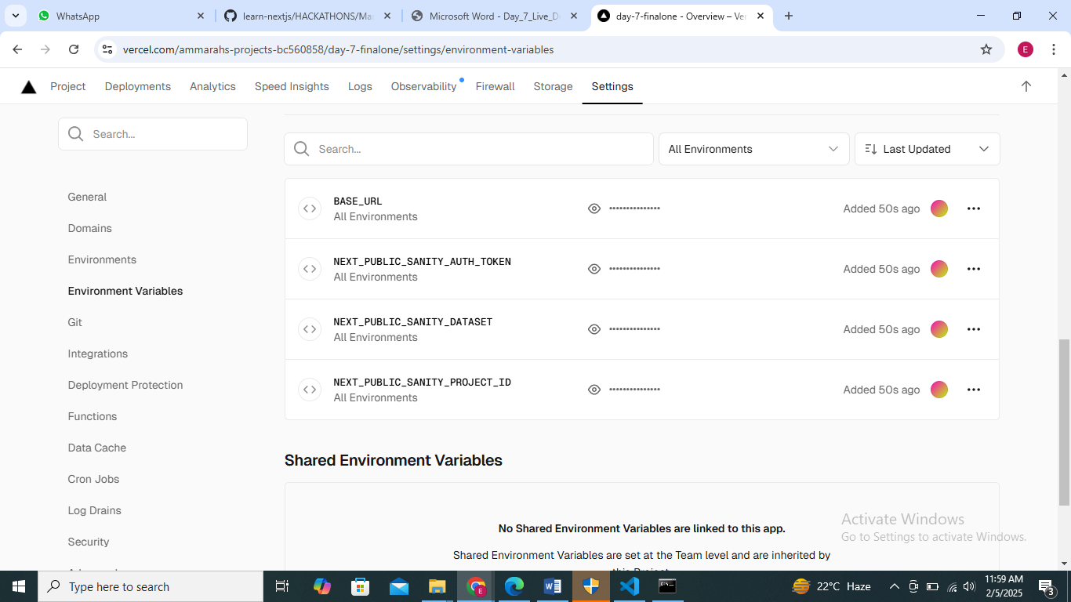

**Enable HTTPS and SSL:** Here is My Link;

[**https://day-7-finalone.vercel.app/**](https://day-7-finalone.vercel.app/)

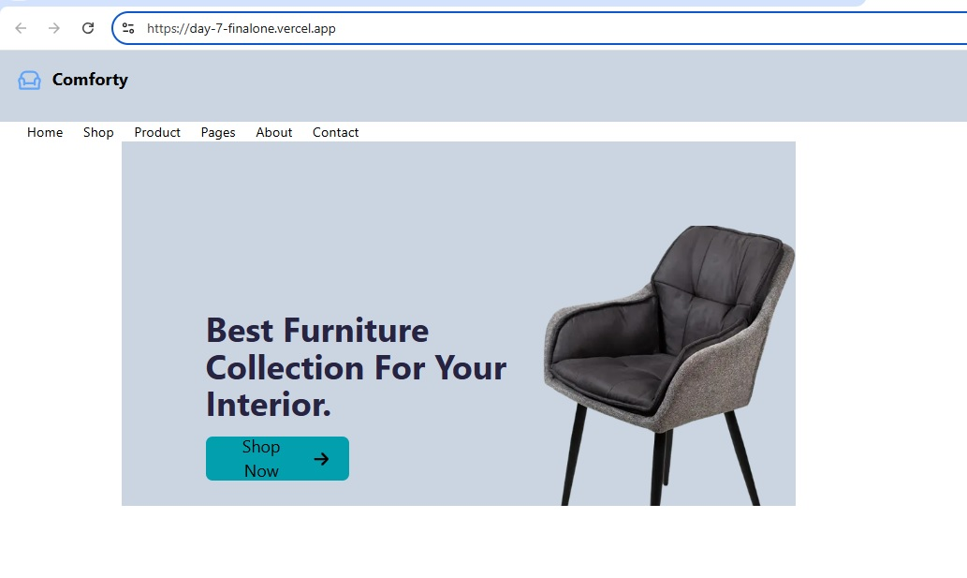

**Performance Optimization:**

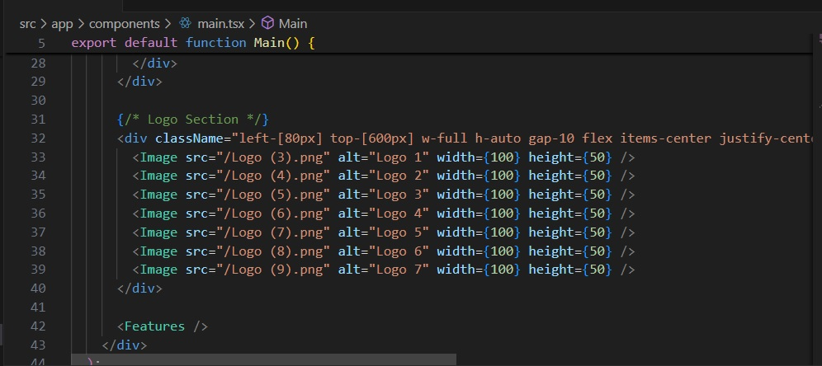

**• Setup Monitoring Tools like Sentry in sentry.config.js:**

const { withSentryConfig } = require("@sentry/nextjs");

const moduleExports = {

    //

};

const SentryWebpackPluginOptions = {

    silent: true,

};

module.exports = withSentryConfig(moduleExports, SentryWebpackPluginOptions);

**Checklist for Day 7:**

Deployment Checklist:

• ✔

Security Checklist:

• ✔

Post Go Live Checklist:

• ✔

Business Pitch Deck:

• ✔

Resume PDF:

• ✔

**ThankYou Note:**

I want to sincerely thank you for your dedication and expertise in the field of IT. Your guidance has not only deepened my understanding of technology but has also inspired me to explore and innovate.

Sir Ameen Alam, Sir Hamza Syed, Sir Anas, your ability to simplify complex concepts and your patience in teaching have made a significant impact on my learning journey. Your passion for IT and commitment to helping students succeed is truly admirable.

Thank you for being such an incredible mentor and for equipping us with the skills we need to thrive in the tech world.

With appreciation,  
Ammarah